Instructions for using Power Take Off (PTO) V

PTO is a device that is used to provide engine power to special equipment directly from the engine or through the transmission.
Operation & using of the Power take off (PTO)

When Operating Power Take Off

Caution

Make sure there are no people or objects around and above the vehicle before operating PTO
When operating the PTO, be sure to place the gearshift level into the “N” position, firmly pull the parking brake level & keep the brake pedal fully depressed with your right foot
Don’t operate PTO while the vehicle is moving

Advice

PTO cannot be engaged during fast idle control immediately after cool engine startup or when the engine speed is increase with the idling control knob. Wait until engine warm up completes or return the idling control knob to the lowest setting before operating the PTO.

Note

[FAST IDLE CONTROL]
A supplementary function to warm up the engine by automatically
increasing the idling speed while the engine is cold.

SWITCH – type PTO
Start

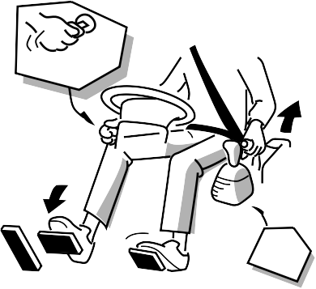

To Engage the PTO
- Fully pull up the parking brake lever, and with the vehicle at a complete stop, set the gearshift lever in the “N” position. Then start the engine

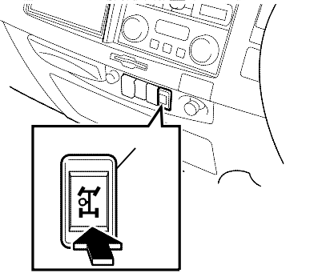
- Depress the clutch pedal fully, and after waiting for short time, press the PTO switch. At the time, the PTO indicator light in instrument panel will come on

ADVICE

If the PTO switch is set to the on
position immediately after pressing down the clutch pedal, a gear grinding noise may occur or the PTO may not engage. Operating the switch before the vehicle has come to a complete stop can also have the same consequences.

PTO indicator light

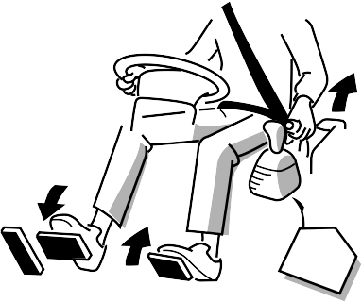
- Remove the foot slowly out of the clutch penda
- Operate the special equipment by following the special equipment’s instruction.

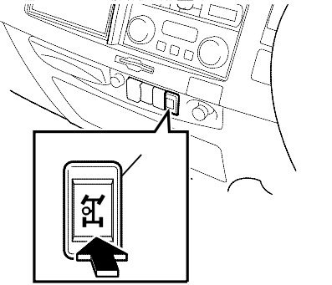

To Disengage the PTO

- Press the PTO switch while
depressing the clutch pedal.
Then make sure that the PTO
indicator light in the instrument panel
goes out and PTO drive is stopped
- Remove the foot slowly out of the clutch pedal

CAUTION
PTO indicator light

Before starting vehicle, you should confirm the following:
    - The special equipment is in a safe condition for driving
    - The PTO switch is in the off position

